 **TIJUANA INSTITUTE OF TECHNOLOGY**

**ACADEMIC**

**DEPARTMENT OF SYSTEMS AND COMPUTATION COMPUTER**

**SYSTEMS ENGINEERING**

**SEMESTER**

FEBRUARY- JULY 2022

**SUBJECT**

BDD-1703SC9C Data Mining

**Activity**

Evaluativo Practice 4

**Teacher**

MC JOSE CHRISTIAN ROMERO HERNANDEZ

**Student**

17212327 -Alderete Delgado Angel Esteban

17210659 - Villegas Carmona Damaris

**Instructions**

Implement the K-Means clustering model with the Iris.csv dataset found at https://github.com/jcromerohdz/iris using the kmeans() method in R. Once the clustering model is obtained, perform the corresponding data visualization analysis kmeans() method in R. Once the clustering model is obtained do the corresponding data visualization analysis.

At the end of the development explain in detail what the K-Means clustering model consists of and which K-Means clustering model and what were your observations in the data visualization analysis. Data visualization analysis.

**Development**

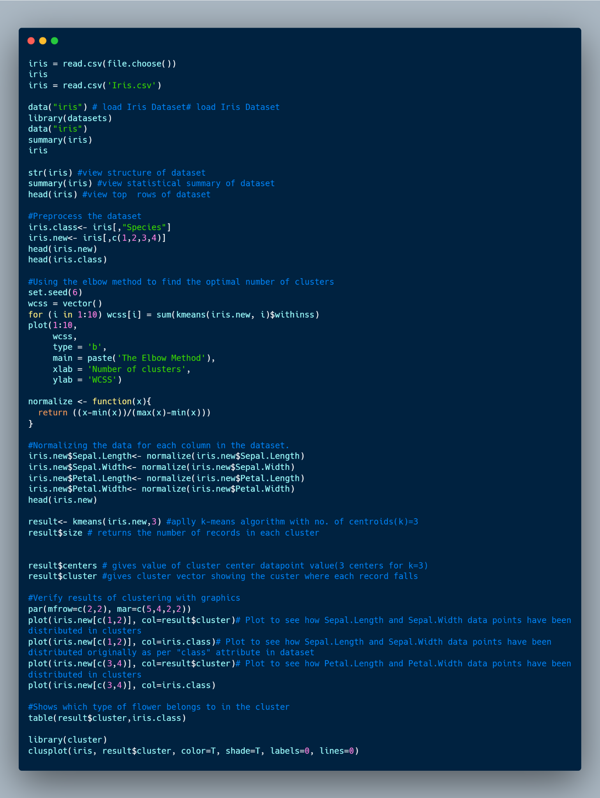

By means of the file.choose() method, we call the csv from iris.

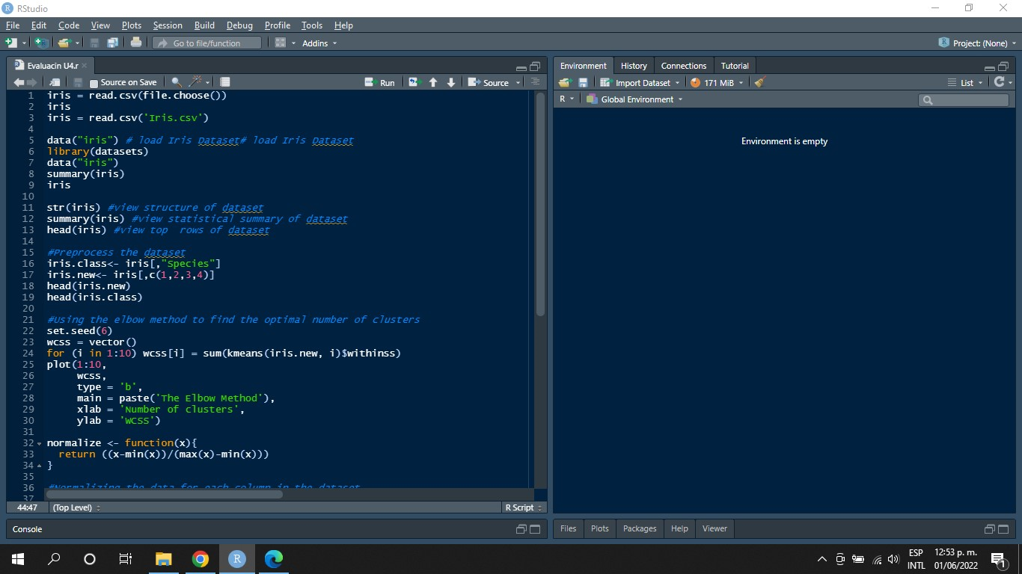

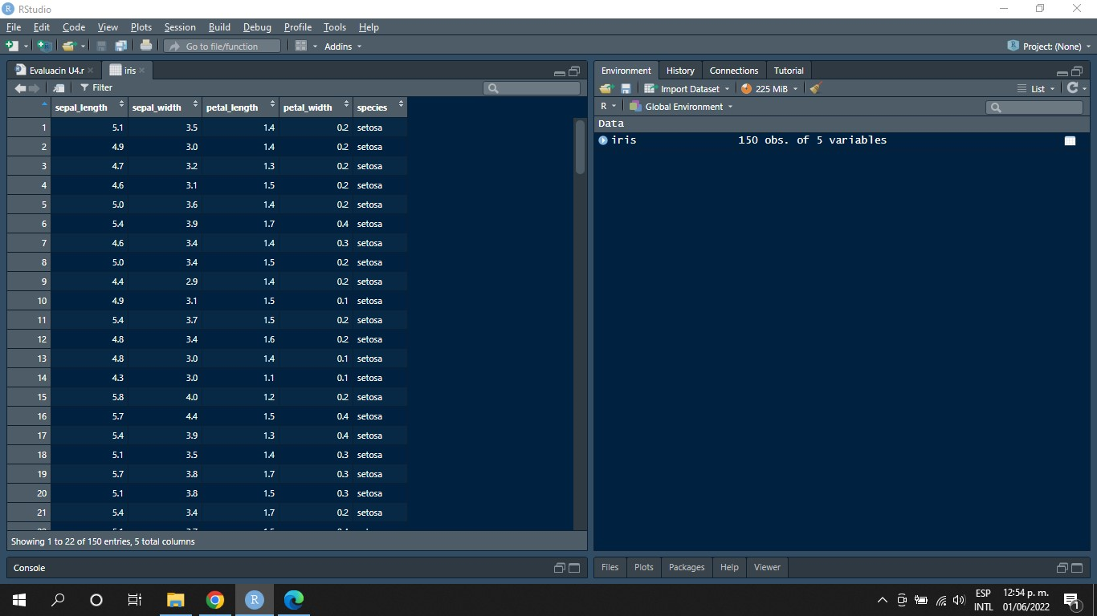

In order to get a better understanding of the data, we will use the following functions:

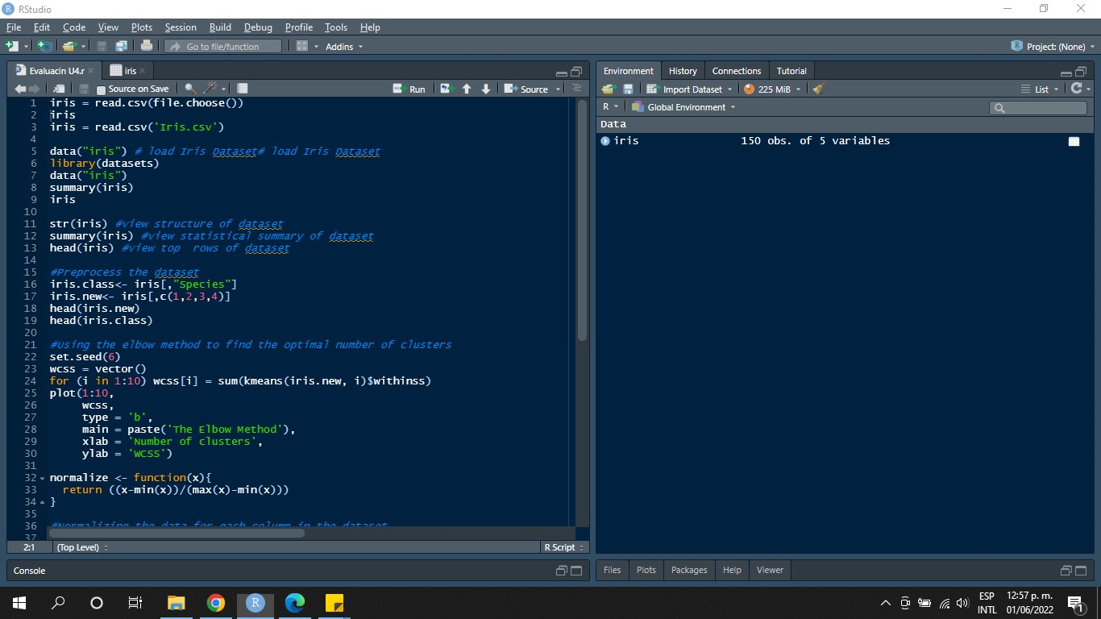

The first function str(iris), works to visualize the structure of the data.

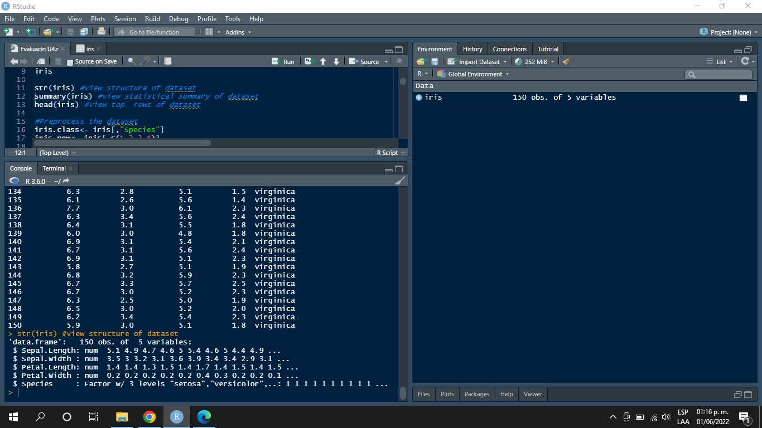

The second function summary(iris), helps us to make a statistical summary of the data.

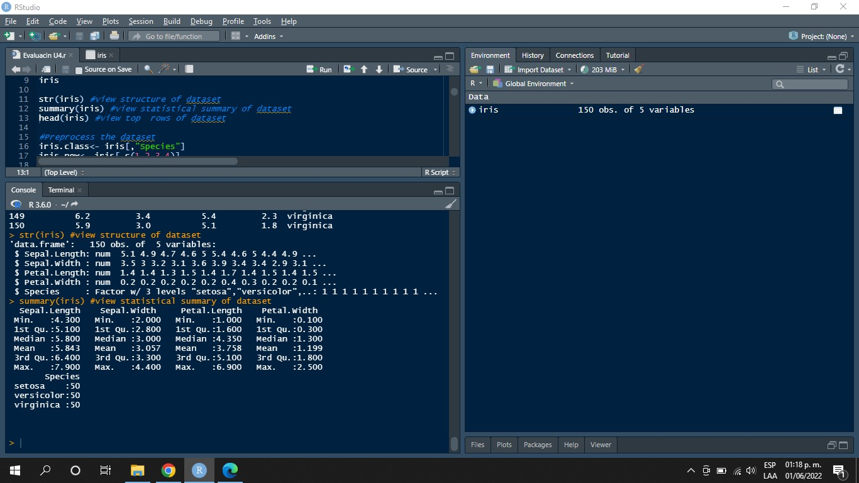

And finally the third function head(iris), helps us to visualize the first tuples of the data.

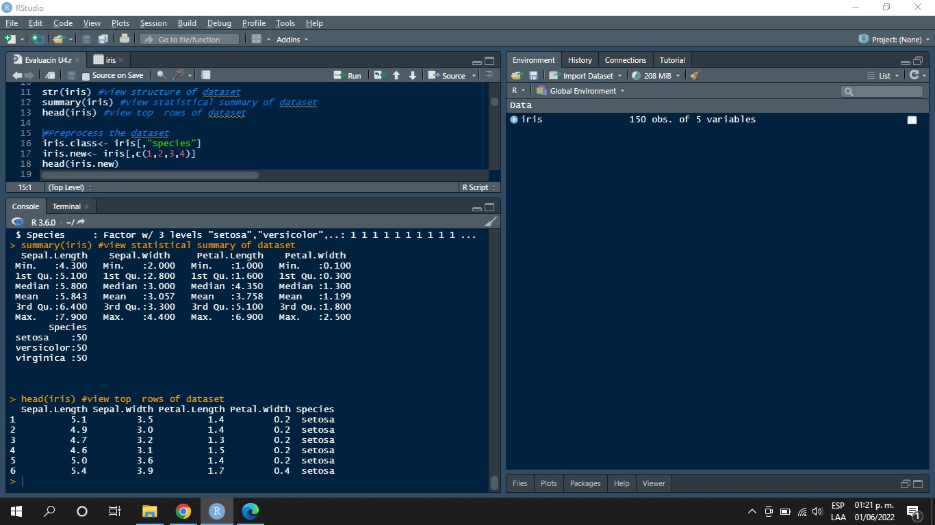

In order to prepare the dataset for data normalization, the following methods are used:

* A new data set named "Iris.new" is created and the first four columns of data are inserted into it. The first four columns of data are inserted.

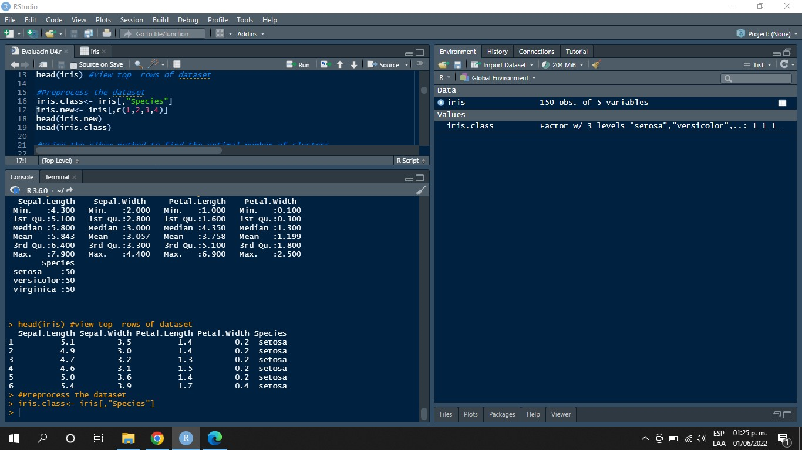

* Another new set "Iris.class" is created where the species belonging to each tuple is stored. belongs to each tuple.



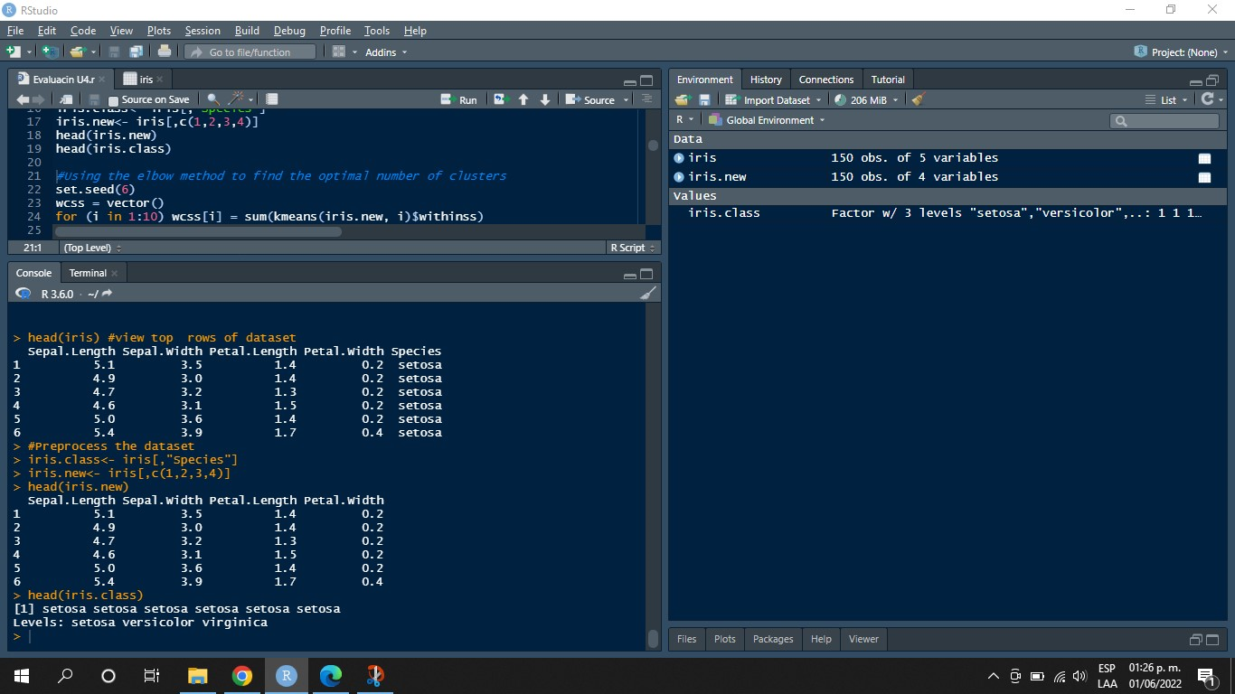

Elbow Method

To obtain the appropriate number of clusters it is necessary to apply the elbow method. It consists of the sum of total squares within the data set as a function of the number of clusters of the number of clusters. The location of the elbow is often considered as an appropriate indicator of clusters, because it is appropriate indicator of clusters, because it means that adding another cluster does not improve the partition much the partitioning

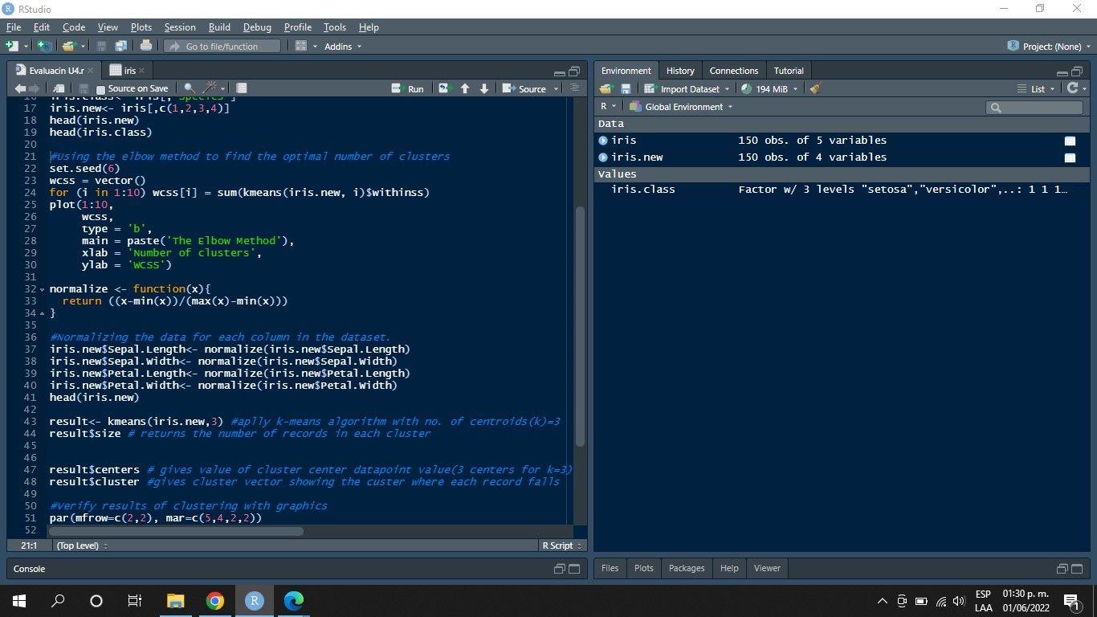

The data are normalized for each column of the data set.

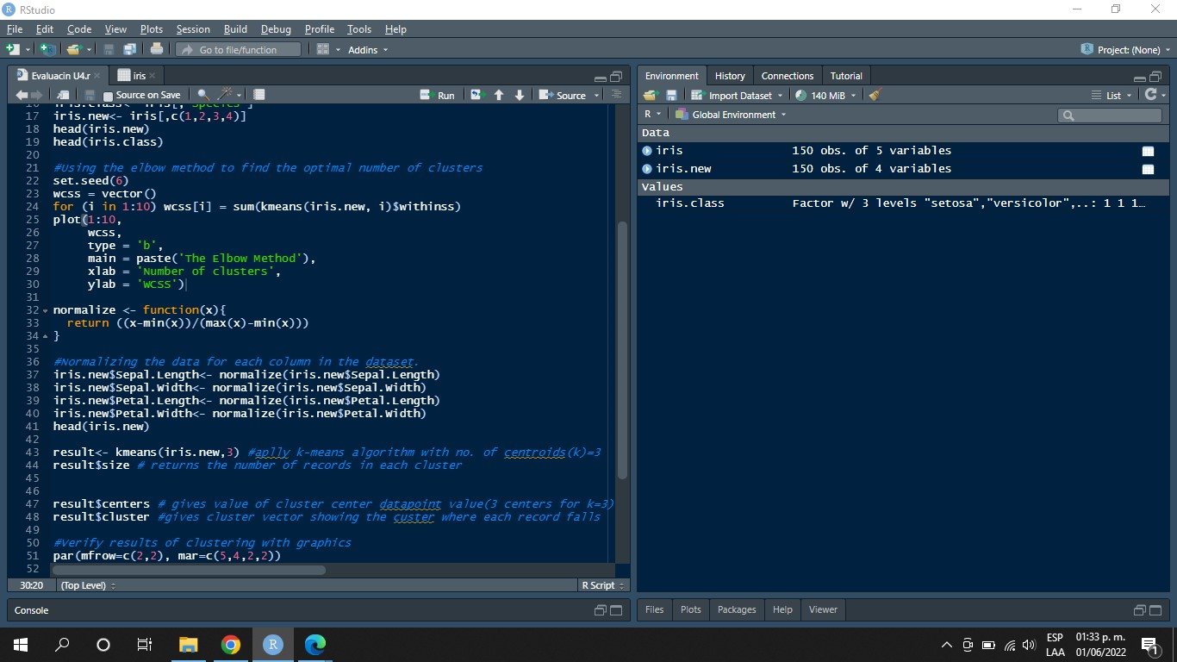

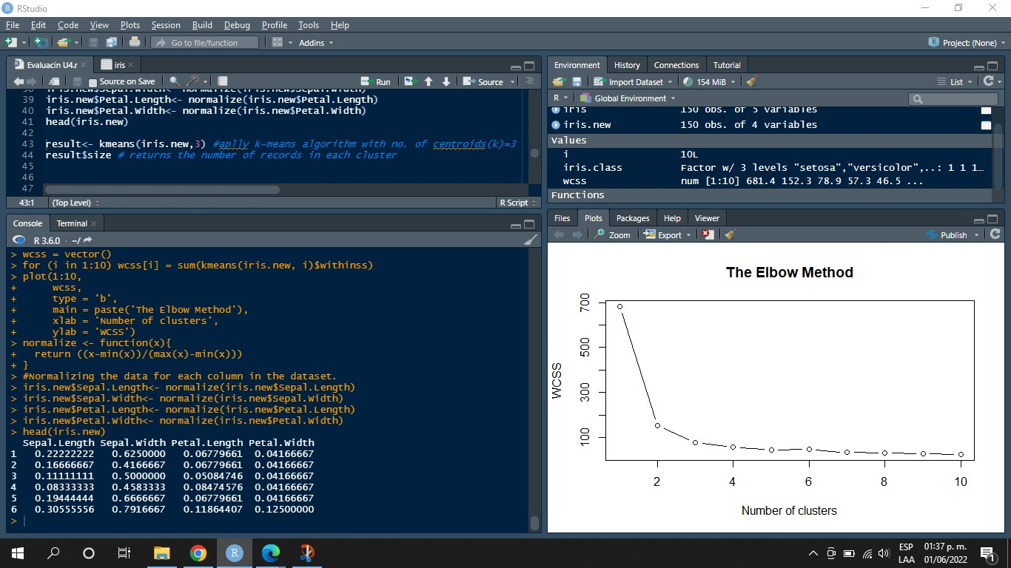

To obtain the result of the K-Means algorithm, you need to use the function kmeans().

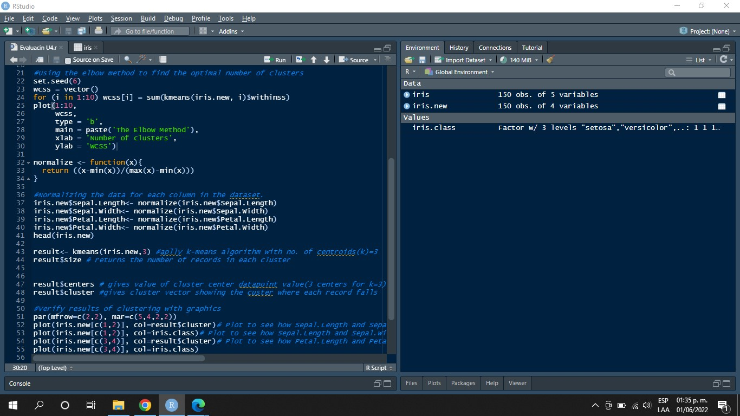

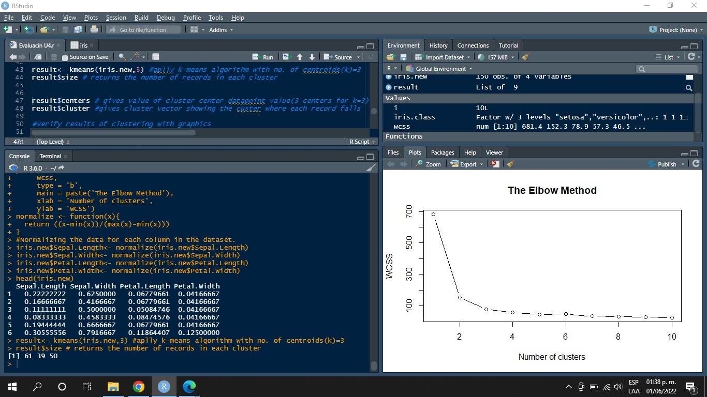

In order to obtain the value of the cluster center, the approximate values of each column of the three centers.

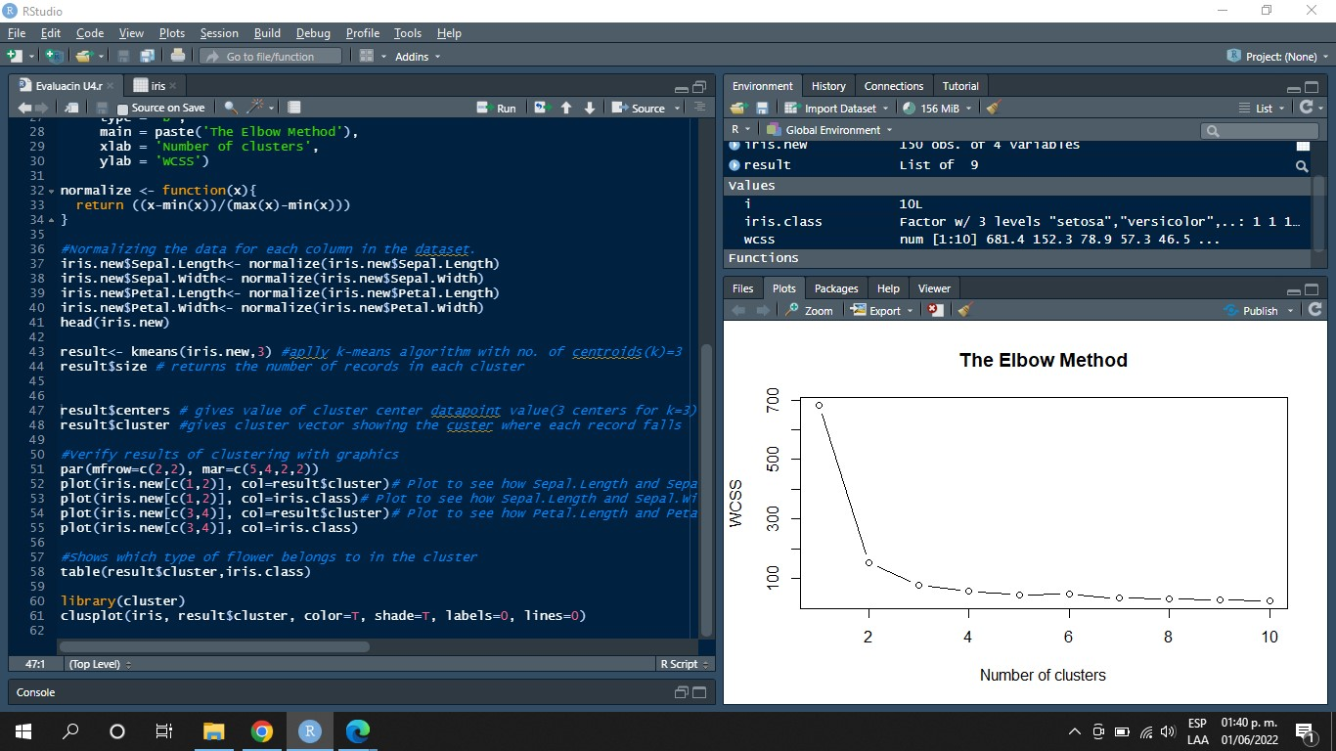

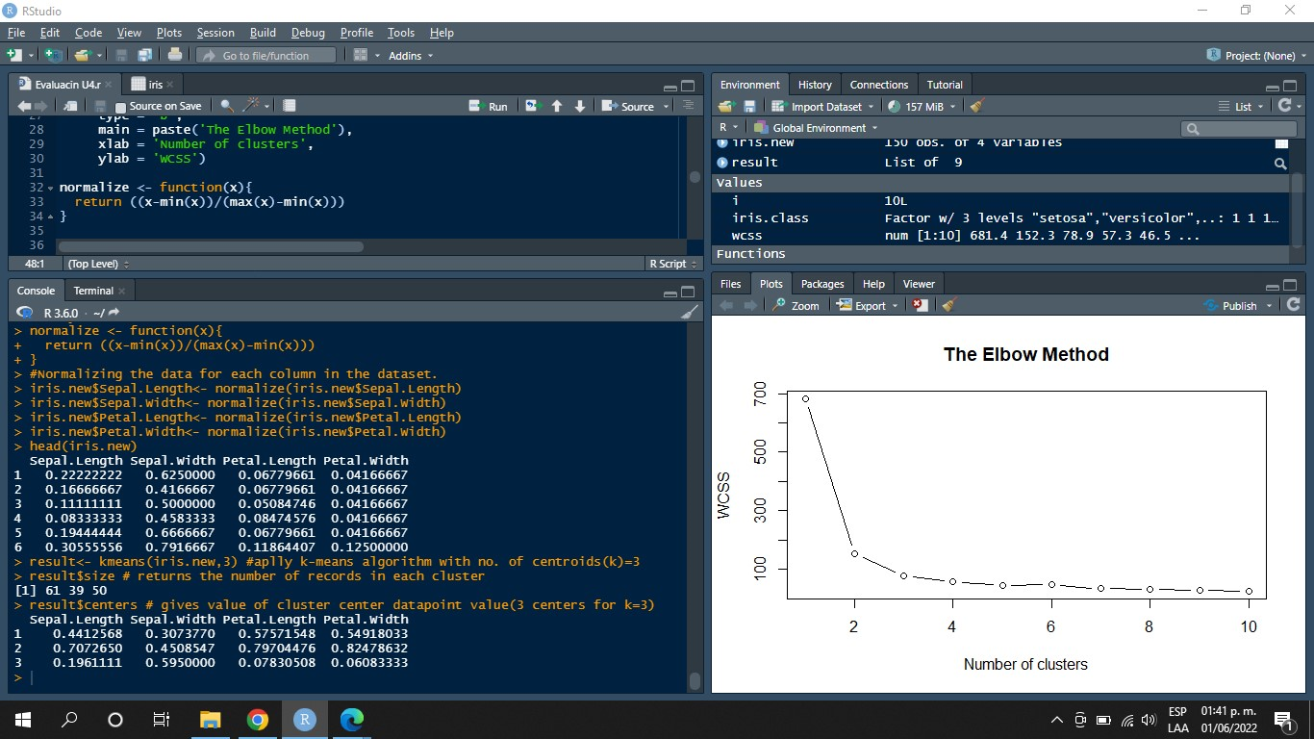

In order to visualize in which species each tuple in the dataset fell.



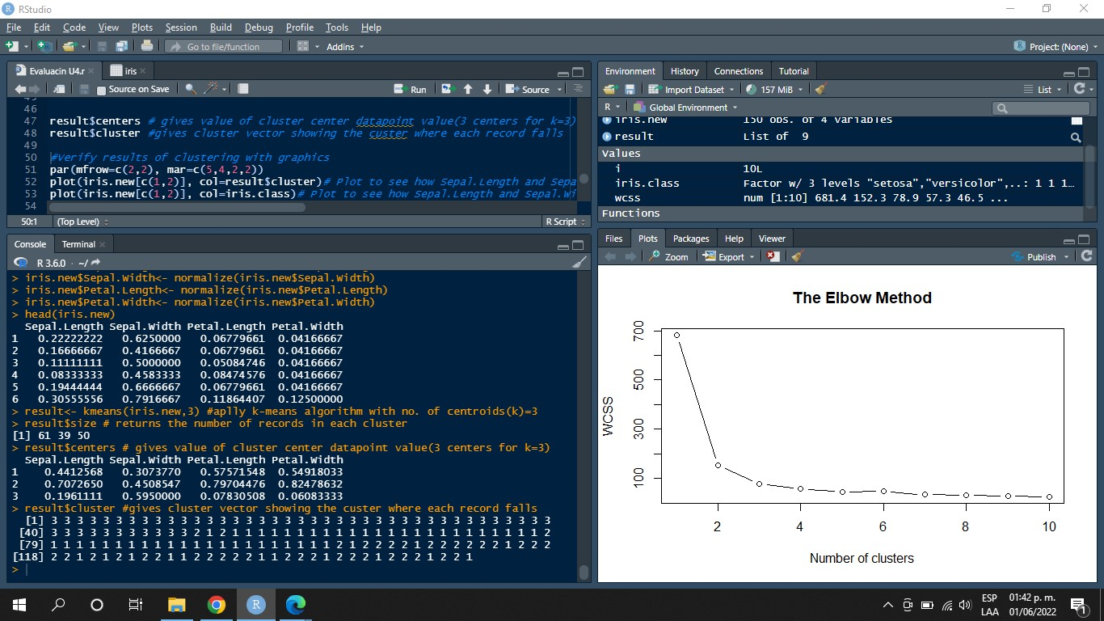

The 'par' function helps us to integrate parameters for graphs. Parameters can be specified by arguments. The graphs will be arranged on a 4x4 grid.

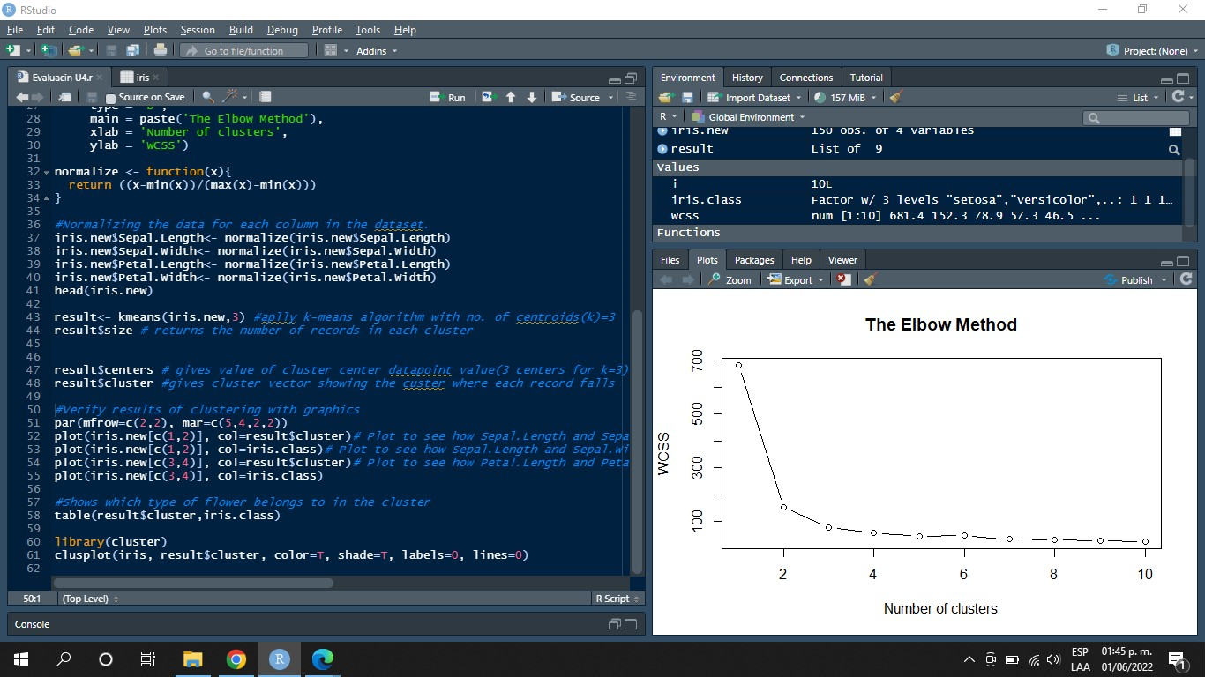

The graphs show comparisons between different flower characteristics. In the first graph, the width of a flower and the length of a flower are compared; the second, the length of the petal and the length of the sepal; the third, the width of the sepal and the petal; the fourth, the width of the petal and its length.

Finally, a two-dimensional graph showing where the different types of flowers are found is shown.

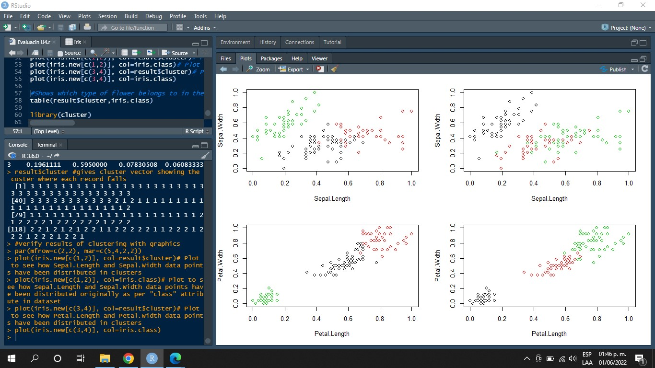

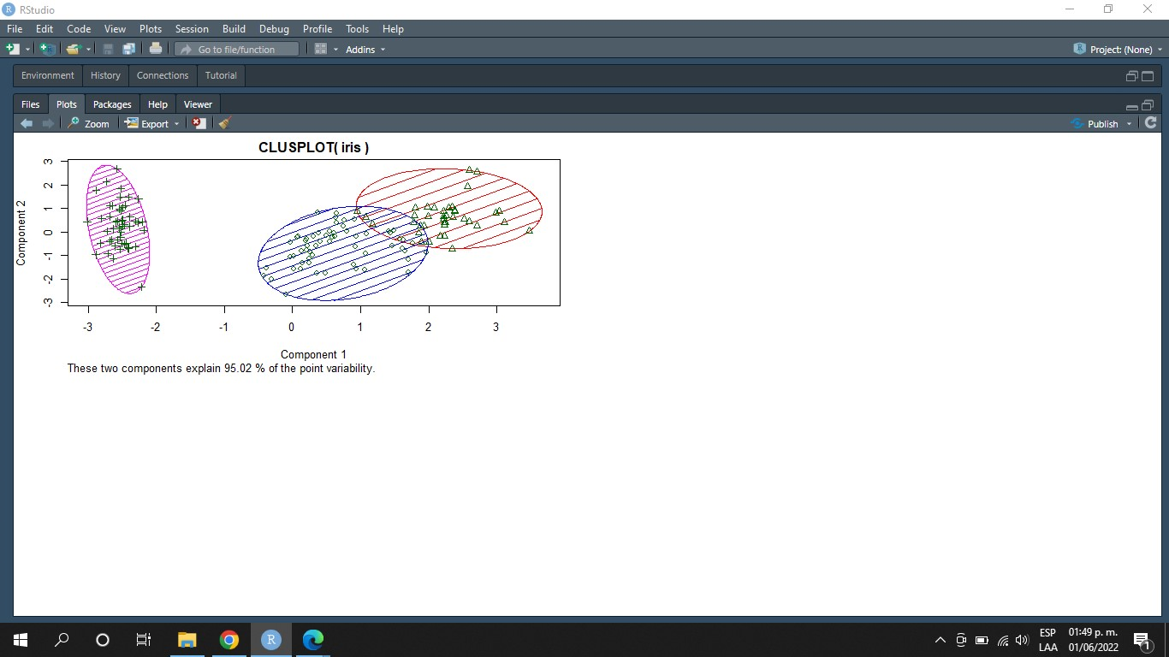

**Conclusion**

This practice shows that it has things to teach as it is a model that allows us to group data and find the points with fewer errors means that it is a model that cares about its accuracy, this model works for data grouping, as well as identifying different intermediate points of the data group, in conclusion, it is a model that has a fairly good accuracy and that for the classification is one of the models to be used.

**References**

Anand, S. (2017, February 9). *Finding Optimal Number of Clusters*. R-bloggers. Retrieved June 1, 2022, from <https://www.r-bloggers.com/2017/02/finding-optimal-number-of-clusters/>